**2016 QI Annual Evaluation**

1. **Transitions in Management: Inpatient Facility to Primary Care Practitioner**

Hospital readmissions are common, costly and negatively impact health outcomes. Data from the 2007 Healthcare Cost and Utilization Project (HCUP) on all-cause readmissions among non-elderly Medicaid patients revealed that Medicaid readmission rates were higher than commercially insured patients. For Medicare patients, nearly one in five were readmitted within 30 days of discharge from a hospital stay and estimates of the cost of these potentially preventable readmissions equates to $12 billion dollars annually.[1] Readmission rates can be indicators of the need for better continuity and coordination of care.

The Key Performance Indicator (KPI) Reports tracks Inpatient Readmission Rates for Medi-Cal, L.A. Care Covered, and Medicare based on the unadjusted HEDIS specification for All Cause Readmissions.

**Readmission Data Monitoring**

1. **KPI Reports – Inpatient 30-day Readmission Rates for Medi-Cal, CMC, and LACC**

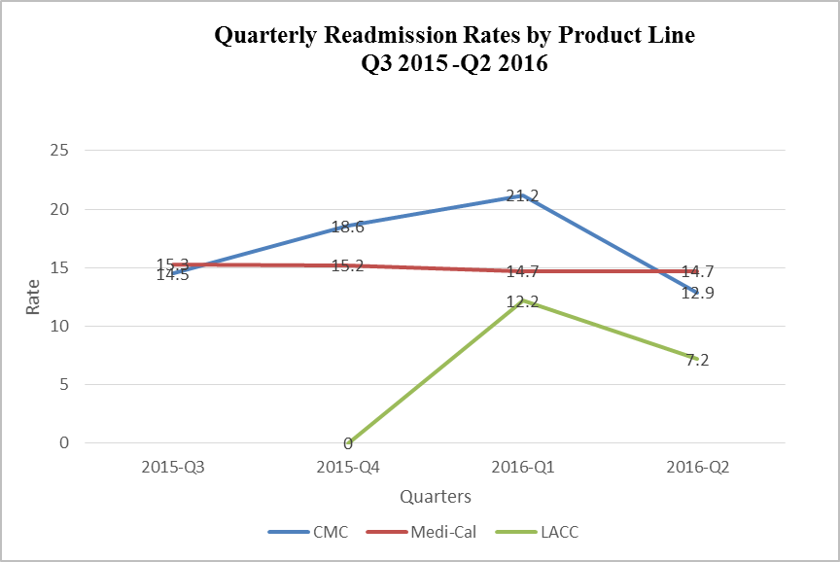

**Quantitative and Causal Analysis –Readmissions**

For Medi-Cal from the third quarter of 2015 through the second quarter of 2016 (July 2015-June 2016), the average Readmission Rate was 15.0%. The rate has dropped from last year’s (September 2014-June 2015) reported rate of 17.2%.

For Medicare-CMC from the third quarter of 2015 through the second quarter of 2016 (July 2015-June 2016), the average Readmission was 17.1% and was lower than last year’s (September 2014-June 2015) rate of 19.6%. This rates corresponds to a one star based on the 2017 Medicare Star Ratings.

For LACC, there was more variability month to month in readmissions, likely due to the smaller membership size. In addition, third quarter data from 2015 was not available. The average Readmission Rate for the three quarters depicted in the graph was 10.4%. However, due to the small population it is difficult to draw any conclusions at this time.

Discharge from a hospital is a critical transition point in a patient’s care and organizations across the country are focused on hospital discharges as a high-yield opportunity to improve outcomes and reduce costs. However, knowledge of patients being admitted and discharged from hospitals is a barrier for many groups within L.A. Care’s network. PCPs may not know when patients have been discharged which has a significant impact on patients accessing time-sensitive follow-up services.

**Opportunities for Improvement**

The rate for Medi-Cal and Medicare has dropped two points for both product lines but there is still room for improvement. For Medicare-CMC, L.A. Care participated in a QIP for Transition of Care (TOC) to reduce readmission rates. Leading groups were interviewed to assess current efforts for TOC and to identify best practices. Most groups conduct TOC and discharge planning similarly across all lines of business. A TOC Readiness Assessment Tool was developed to help groups assess their current efforts and commit to enhanced TOC processes, including medication reconciliation, early inpatient assessment for readmission risk and care management across the transition. One of the key challenges for many groups is the timely transfer of key data across care settings. Improving the timeliness of data sharing between the hospital, L.A. Care, and the IPAs/PCPs will have a positive impact on coordination and continuity of care for L.A. Care members.

**Intervention to act on Opportunity: HIT eConnect**

To increase timeliness of data sharing related to inpatient admissions, L.A. Care is taking action to enhance its network’s ability and infrastructure to communicate (share data) with L.A. Care’s Utilization and Care Management departments, IPAs and PCPs about which members are admitted inpatient. Timely exchange of this information can prompt the member’s PCP/staff to make follow-up calls and schedule appointments with members’ post-inpatient discharge leading to a potential reduction of readmissions.

**Measuring Intervention Effectiveness: HIT eConnect**

Currently, L.A. Care receives hospital face sheets, clinical notes, and discharge summaries by fax. Given this lack of infrastructure to support efficient and timely communication of member admissions to the inpatient setting, L.A. Care has developed a pilot program called eConnect. In 2014, L.A. Care’s eConnect pilot program began working to enhance the networks infrastructure to electronically receive member inpatient admission data from hospitals by establishing an ADT (admission, discharge, and transfer) feed from hospitals as well as establishing access by L.A. Care’s Care Management team to Hospital EHRs. ADT information is shared (via an online portal) with L.A. Care’s Utilization and Care Management department when members have been admitted to the inpatient setting; information that can then be shared with IPAs and subsequently PCPs. Thus, this pilot program directly impacts coordination and continuity of care for all lines of business (Medi-Cal, CMC, and LACC) since it offers care managers, IPAs and PCPs “real-time” knowledge of when their patients have been admitted to the inpatient setting.

As of December 2016, 22 hospitals are now able to electronically notify L.A. Care through the eConnect interface upon member admission and 15 out of the 22 hospitals allow access to their EHR. There are an additional five hospitals having set systems in place and in the process of testing the eConnect ADT interface (expected “go-live” in 2017). This is a significant increase from the prior year. In 2015, there were only 10 hospitals that could electronically notify L.A. Care of admissions, discharges, and transfers. The table below list the hospital that are a part of the eConnect pilot program and the actual number of admission being captured at each site or hospital group.

| **Inpatient Admissions Among Active ADT eConnect Hospitals for 2016** | | |
| --- | --- | --- |
| **Hospital Group** | **Hospital Site** | **Admissions Captured** |
| Adventist | Glendale | 3,481 |
| Adventist | White Memorial | 2,665 |
| Alta | Culver City | 1,055 |
| Alta | Hollywood | 540 |
| Alta | Los Angeles | 975 |
| Alta | Norwalk | 320 |
| Alta | Van Nuys--Mental Health Facility | 617 |
| Alta | Bellflower Community--Mental Health Facility | 293 |
| Alta | Foothill | 6 |
| Citrus Valley | Foothill Presbyterian Hospital | 779 |
| Citrus Valley | Inter Community | 914 |
| Citrus Valley | Queen of the Valley | 3,889 |
| Memorial Care Systems | Long Beach Memorial | See total below |
| Memorial Care Systems | Miller Children’s Hospital | See total below |
| Memorial Care Systems | ***Memorial Care Systems total\**** | 6,602 |
| Providence | Holy Cross | See total below |
| Providence | Little Company of Mary Hospital | See total below |
| Providence | St. Johns | See total below |
| Providence | St. Joseph | See total below |
| Providence | Tarzana | See total below |
| Providence | ***Providence\**** | 9,662 |
|  | Huntington Memorial | 1,056 |
|  | Valley Presbyterian Hospital | 2,479 |
|  | Martin Luther King | 714 |
| **Total Admissions for active ADT eConnect Hospitals (% of total Admissions /year)** |  | 36,074 (39.2%) |
| **Total L.A. Care Admissions/year for all Hospitals 10/01/2015-9/30/2016** |  | 91,910 |
| *Only Hospital Group data is available. | |  |

**Intervention Effectiveness: Discussion – Readmissions and eConnect**

The goal of the project is to capture 69.9% of the data by the end of 2017. Last year the project was capturing an estimated 18.7% of admission. As of December 2016, the project is capturing an estimated 39.2% of total hospital admissions and is on track to meet their goal by the end of 2017. Over time, as the timeliness of ADT data exchange improves for the network, it is expected that improvements in data exchange will lead to lower readmission rates, as medical groups and providers are better able to identify high risk patients and provide more timely continuity and coordination of care.

1. 1 MedPAC. Report to Congress: Promoting Greater Efficiency in Medicare. June 2007. http://www.medpac.gov/documents/Jun2007.